Bury My Heart at Wounded Knee
Characters you need to know:
Sitting Bull
Henry Dawes
Charles Eastman
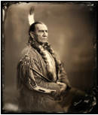
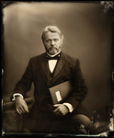

By 1876 most of the nation’s American Indians had been forcibly relocated to . In the Dakota Territory, had settled with his people on the Great Sioux reservation, becoming wards of the …but other Sioux leaders and , saw this as defeat and continued to live in the way. Their resistance was legendary. Then an economic depression struck. And was discovered in the … on land.
What event takes place in the opening of the film?

Briefly describe each of these characters, their role in the film, and their feelings/opinions of relations between the United States and Native Americans
Ulysses Grant

Henry Dawes

US Military

Red Cloud

Sitting Bull

Charles Eastman

Elaine Goodale

Wovoka

Give at least three specific examples of Americanization of Natives shown in the film.

Name at least three specific examples of hardships faced by Natives in the film.

Describe in detail the conflict at Wounded Knee Creek. What happened? Why? What was the result?

Presently, what has our court system said about the Sioux and Black Hills situation? (Read the credits)

