Name Date Class
Horizontal or Vertical Integration?
Directions: Use your knowledge of these terms and the chart below to decide if the following scenarios are horizontal or vertical integration.
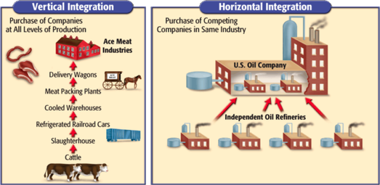
- Walmart buys out the stock for Kmart.

- Taco Bell buys all the local Mexican restaurants in downtown Raleigh.

- McDonald’s purchases nation-wide farms to source their dairy and meat products.

- Disney purchased 20th Century Fox (finally merging the two Marvels film universes!)

- American born Chrysler is purchased by Fiat in Italy.

- 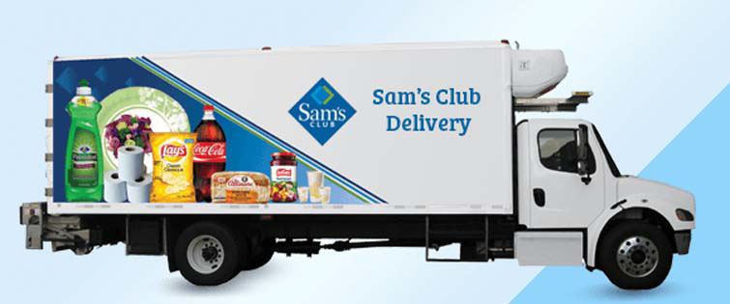

- Gap Retailer owns clothing factories in China.

- 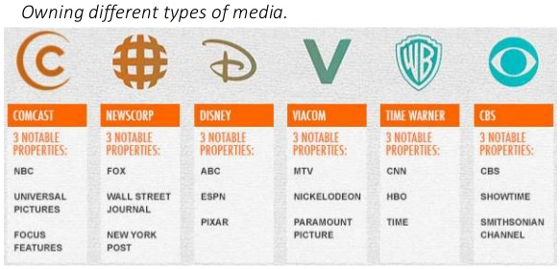

- Google purchases YouTube and IMDB.com

- Microsoft owns a plastics plant in Minnesota.

